MiniProject Title: Flowerplicity

Authors: Ariel Maniago & Rosie Conde

# Project Overview

## A flower shop is a business that specializes in the sale of flowers and other related products, such as vases, gift baskets, and bouquets. They are typically found in high-traffic areas, such as shopping centers and high streets. When it comes to marketing, flower shops have a few key challenges. First, they must compete with other flower shops in the area, as well as with supermarkets and online retailers that also sell flowers. Additionally, the product is perishable and has a limited shelf life, which means that the shop must be able to quickly sell its inventory to avoid wastage. To overcome these challenges, some flower shops post their products through social media platforms to be more competitive and build their strong brand and create unique selling propositions at the same time to create a sense of community. But at the same time, they can easily ignore the bash comments that are thrown at them, which leads to frustrations and depression, and sometimes can lead to not being more competitive.

## As developers and researchers, we came up with this project to develop a comprehensive solution through the use of modern technology. The solution consists of having a floral trade between flower shop owners, their customers, and local flower growers in a one-stop-shop kind of setup. Also, to avoid harsh and disruptive comments to be more competitive when it comes to their business. At the same time, it streamlines its operations, improves customer satisfaction, and increases revenue. It involves flower arranging, floral design, add-on gift ideas, and often flower delivery and tracking systems, marketing and sales promotion, reporting, and analytics. The flower shop owner is to provide quality of good services such as quality flowers and fair pricing. At the same time, their customers will also easily search and locate the nearest shop to lessen the hassle of commuting distance by distance whether the floral product of their want, needs to be picked up or delivered.

In summary, "Flowerplicity" is a term that can be used to refer to a simple, easy, and elegant way of buying and receiving flowers, which is aimed to make the process more convenient and stress-free for the customers, flower shop owners as well as local flower grower.

## Statement of the Problem

The proposed project aims to address the problems, that flower shop owners have to face pertaining to marketing.

Specifically, this project also aims to give solution on the following questions:

1. What are the perishable and seasonality of floral products?

2. What are the difficulties in customizing, presenting and delivering the customer's floral needs on time.

3. What is the reason that some of flower shop owners, local flower farm grower needs to overprice their floral products?

4. What are the difficulties in managing/monitoring inventory.

## Project Solution

The general solution or objective of this project was to develop “Flowerplicity” to address the following

1. Flowers are perishable, which means they have limited shelf life when they cut their stem and they begin to deteriorate. Seasonality means that different flowers are available at different times. To achieve their operational goals, they develop relationships with local flower shop growers to secure the freshness of flowers by ordering the posted supplied floral products on this website.

2. Posting precise images and video clips and also checking the details, time delivery tracking of the certain product, and chat conversation to avoid miscommunication and hassle between customers and flower shop owners.

3. Some of the reasons may overprice their floral products due to some reasons requiring a significant investment in shop rentals and labor. To cope, the solution to this is they are offering discounted delivery coupons and sales promotions for different kinds of events.

4. The difficulties in managing or monitoring the inventory are due to some reasons such as human error, incorrect data entry or misplacement of inventory, and no point-of-sale system. To correct this, the said project has an inventory monitoring and management and POS system to address these kinds of difficulties.

# System Features

## This part discusses the overall features of the system. It describes all the functions for each module such as the Flower shop owner account module, customers account module, local flower growers/supplier account module, log-in and Registration module for the flower shop owner, customers, and local flower grower/supplier, Inventory Monitory management module and Change Password module, delivery and real-time tracking module, blog posts module, contact us module of how to improve the system, chat module both between users and admin in charge and that will serve as a guide to users in understanding the flow of the system. These are the following details for every module:

## Sign up and Log in module

In this module user will register the name of their shop, username, email address, and password and confirm the password. After registering their account, it will redirect them to confirm the email address, and if successfully confirmed, they can now proceed to the login module. To log-in their confirmed accounts, they can now log their email address and password.

(include image screenshot on the powerpoint.)

## Account Module (View/Edit Module, Inventory Management Module, POS Module)

1. Flower Shop owners can edit basic information such as the owner's full name, address, email address, and contact number, and can also put their social media-linked accounts of their shop. At the same time, they can also access to monitor inventory management as well as post their floral products to sell.
2. Costumer can edit their profile, such as their full name, contact number, primary address, and email address, and can change their password. They can also buy their floral needs by searching for a certain different floral product.
3. The flower shop supplier account module can view and edit basic information such as the name of their floral farm, address, contact number, and email address. They can also monitor inventory, as well as post their floral products fresh from their farm.

## Delivery and Tracking Module

1. Flower shop owners can view and track of how many costumers purchase their product as well as generate coupons and sales promotions for their floral products. They can also track the delivery in real-time, the information of courier service.

# Customers can view the status of their order including date and time, delivery address, and the name of the courier service. They can also put their promo coupon if an item has a specific promo coupon to avail discount and they can also view the total summation of purchased product. They also view to delivery history to track the previous purchase status.

1. Local flower grower would allow to schedule deliveries and assign them to specific drivers and delivery items. They can also to view and track the location of delivery.

## Blog Post Module

In this module, users can view and read more of the different articles related to this platform. Such as customer satisfaction provided by the flower shop owner or by the local grower. Inspiration stories of the flower shop owner or local flower grower of how they started from a small capital into a successful business.

## Contact Us Module

In this module, user can contact the admin by sending comments or suggestion via email if there are needs to improve the system to be more user friendly.

## Chat Module

In this module, both users can interact with each other if there is a certain problem, whether it involves delivering products or concerns about the customizing of products. In addition, both users can also chat with the admin if there is a technical problem in the system.

# Limitations

The project focuses on developing a web application: “Flowerplicity” is a platform that will focus on easy-to-use transaction by ordering and purchasing pertaining with floral products between users. Like any other product or service, may have certain limitations.

The limitations of the project are:

* Limited delivery area.
* Technical issues.
* Limited customization
* Limited customer service.
* Data privacy

# Theme, Fonts, logo, Technology used

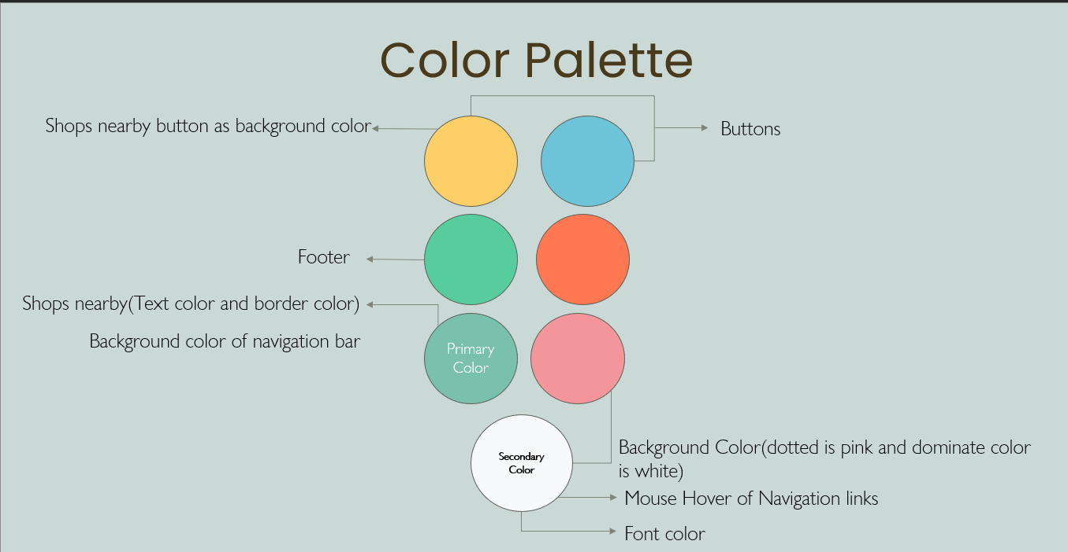

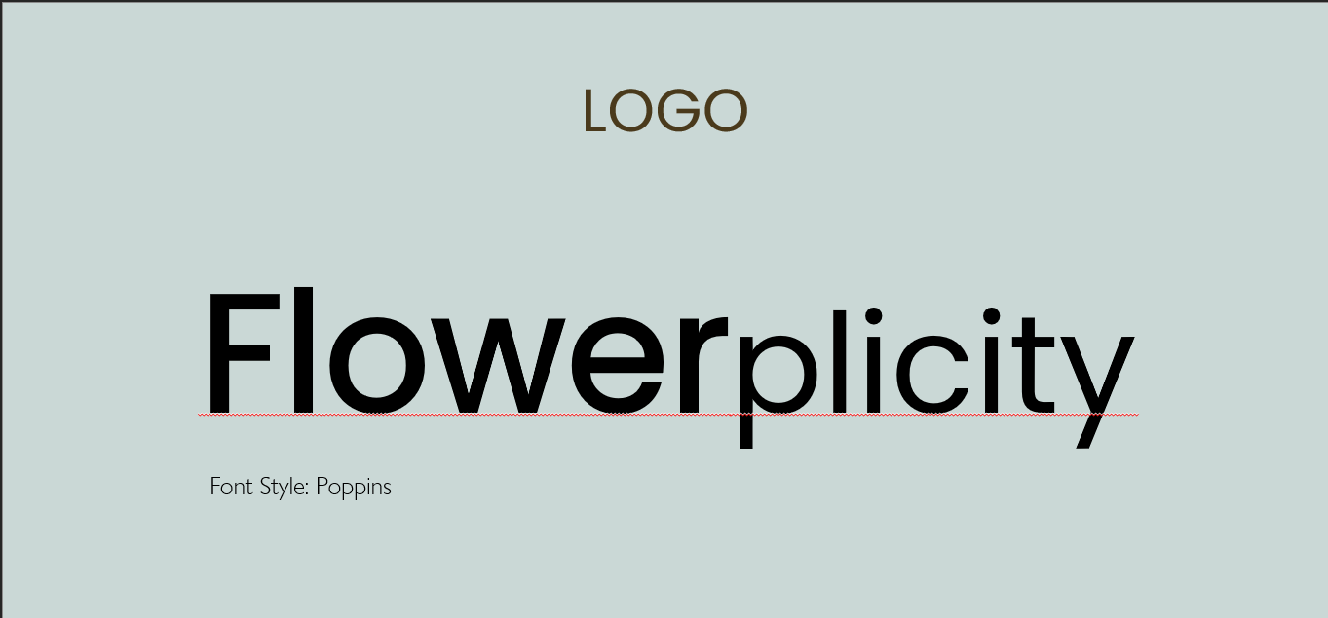



# Site Map

# Mockup/Wireframe

# Web App URL: